EET-2235
Lab #9
PID Controller

Purpose: The student will explore Analog Control using a single loop controller and LabVIEW. In addition, the student will gain experience in tuning a closed loop system.

Background: Closed loop control is a process of manipulating a final control element to maintain a process variable measurement at a predefined set-point value using some type of control device or system. In large and medium sized applications, a Programmable Controller, Distributed Control System, or Data Acquisition System may be used, whereas a single loop controller may be sufficient for many small applications. Regardless of the control system chosen, the most common form of controller used to accomplish closed loop control is the Proportional-Integral-Derivative controller, or PID controller.

The PID controller has three basic adjustable parameters that the technician can alter to stabilize the control loop, namely, the gain (or proportional band), the integral time (or reset), and the derivative time (also known as the rate). The process dynamics basically dictate the value of these parameters. For example, a fast loop may only require the proportional band and reset parameters, also known as a PI controller, whereas a slow loop may require all three parameters. In all forms of the PID controller, the controller is constantly comparing the measured value to a set-point by taking the difference between these two values, resulting in an error. The error then feeds the PID algorithm which computes an output for the controller that ranges from 0-100%. The controller output drives a final control element to a position that will reduce the error between the measurement and the set-point.

A modification to the PID controller that is commonly used in temperature applications is the Time Proportioned Controller. This controller uses the output of a PID controller to proportion the duty cycle of a timed ON-OFF cycle to control the final control element. The output of this type of control loop is a switching device, such as an SSR. The controller operation is the same as a PID controller, except the output will determine the ON and OFF times of the output device. For example, if the timed cycle is set for 10 seconds, and the PID controller computes an output of 40%, then the physical output will be ON for 4 seconds and OFF for 6 seconds, and the cycle is repeated. As the PID controller error is reduced, the ON time will decrease and the OFF time will increase.

Before implementing the live closed loop system, the student will tune a simulated closed loop system to see how the different PID parameters behave.

Procedure: 1. Using the EXCEL Spreadsheet controller, assign a Process gain of 3, a time
constant of 15 seconds and a dead-time of 10 seconds. Use the Ziegler Nichols tuning technique to identify the ultimate gain (K_{U}) and ultimate period (P_{U}). [Ziegler-Nichols method requires the integral and derivative to be set equal to zero and increase the controller gain until the system oscillates periodically.] Assign control values to the PID controller based on the ultimate gain and period.

Attach screenshots for the system with parameters for oscillating periodically and then screenshots for each of the following settings or controller types.

Setting or Controller Type (5 Screenshots) | K  Gain | T_{I}  Integral | T_{D}  Derivative
Oscillates with same peak (Determine K_{U} and P_{U}) | K_{U} | 0 | 0
Proportional Only | K_{U}/2 | 0 | 0
Proportional-Integral | K_{U}/2.2 | P_{U}/1.2 | 0
Proportional-Integral-Derivative | K_{U}/1.7 | P_{U}/2 | P_{U}/8
PV reaches Set Point with Overshoot Less than 20%

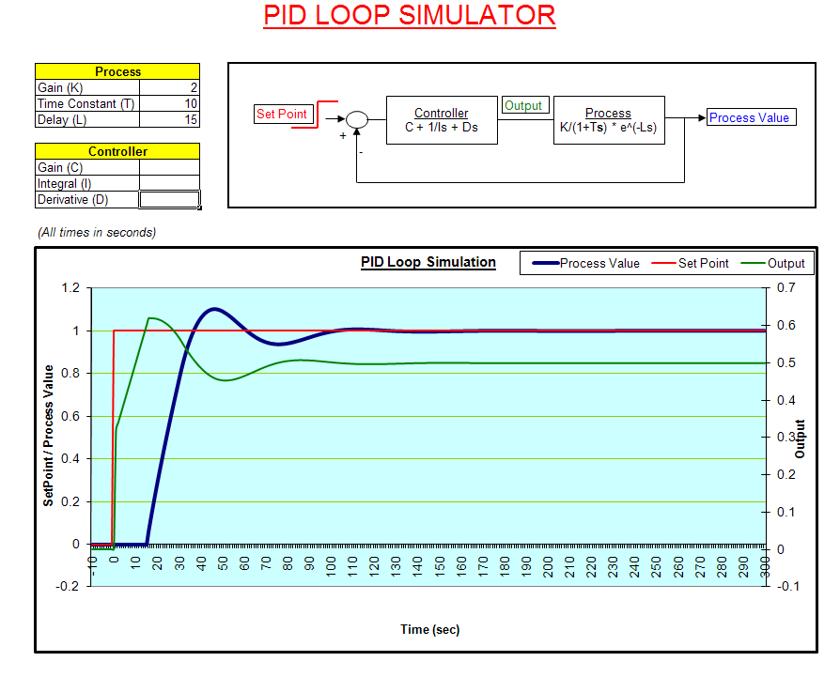

2. Given the Process Board for Temperature Control make the following Field connections:
  - Place the Process board on the NI-ELVIS;
  - Connect the Process board +15Vdc terminal to the NI-ELVIS +15Vdc power supply, and connect the Process board -15Vdc terminal to the NI-ELVIS ground;
  - Connect the +/-Process Variable (temperature measurement) to Analog Input channel #0 (AI0) +/- terminals;
  - Connect the Digital Output (Heater) to the Digital Output point #0 (DIO0). [The + heater connection connects to DIO0 and the – heater connection connects to signal ground.];

3. Run the VI with Automatic control of the heater. Adjust the controller’s PID tuning parameters to stabilize the controller for operation at a set-point of 30ºC, 40ºC and 50ºC. Parameters may be found with or without the fan running. Attach screenshots for different temperatures and parameters used. Indicate whether the fan was used or not.

